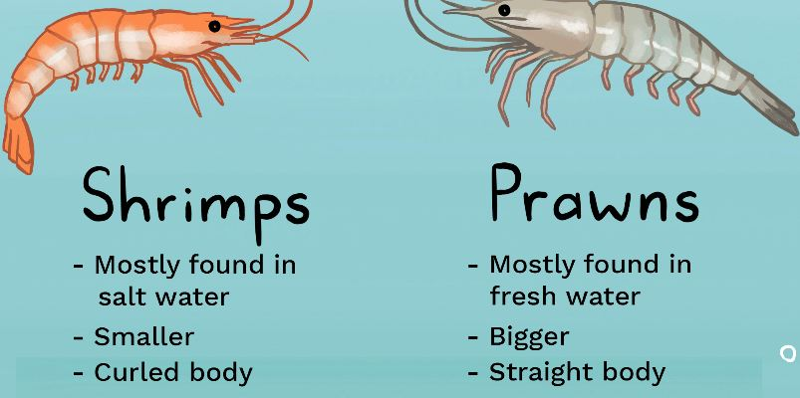
English Vocabulary – Meat & Seafood
Meat Seafood
barbecue  beef  chicken  duck  ham  lamb  pork  rabbit  sausage  veal  venison  heart  kidney  liver  offal | churrasco  carne de boi  frango  pato  presunto  cordeiro  carne de porco  coelho  linguiça  vitela  carne de veado  coração  rim  fígado  miudezas |  | cod  salmon  crab  lobster  octopus  oyster  squid  tuna  sardines  prawns  shrimps  (see image below) | bacalhau  salmão  caranguejo  lagosta  polvo  ostra  lula  atum  vieiras  camarões  camarões

Meat Cuts
steak *  chop  rump  loin / sirloin  minced meat  steak tartare  rib | bife  costeleta  anca / garupa  lombo  carne moída  carne de onça  costela

* steak: rare / medium rare / medium / well done
(a “well-done” steak is tough, and a “medium-rare” steak is tender) (duro / macia)
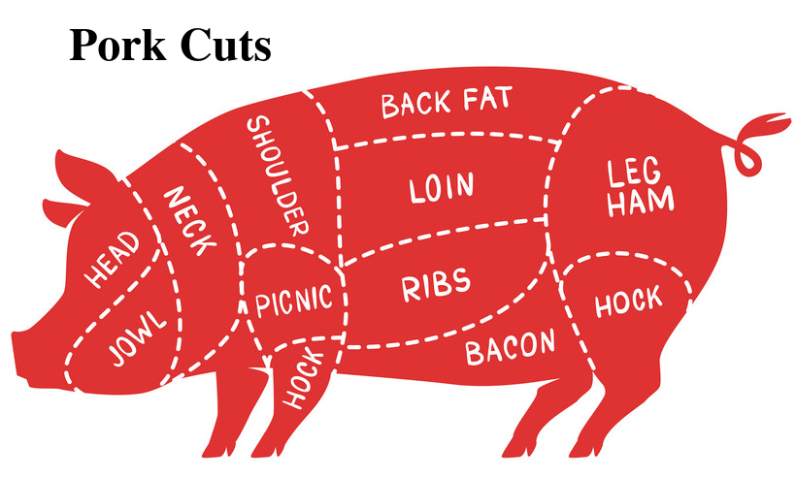
Parts of a chicken
- Wing Asa
- Leg Coxa
- Breast Peito
- Thigh Sobrecoxa

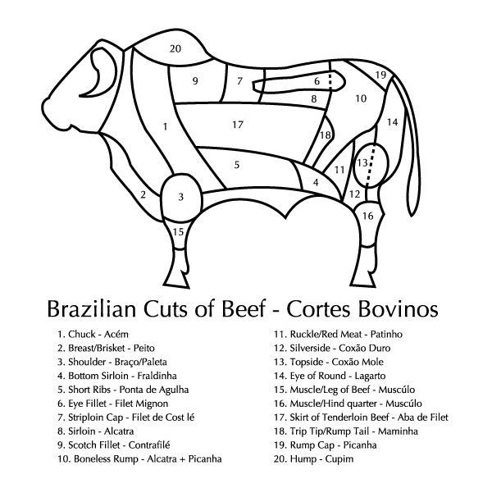
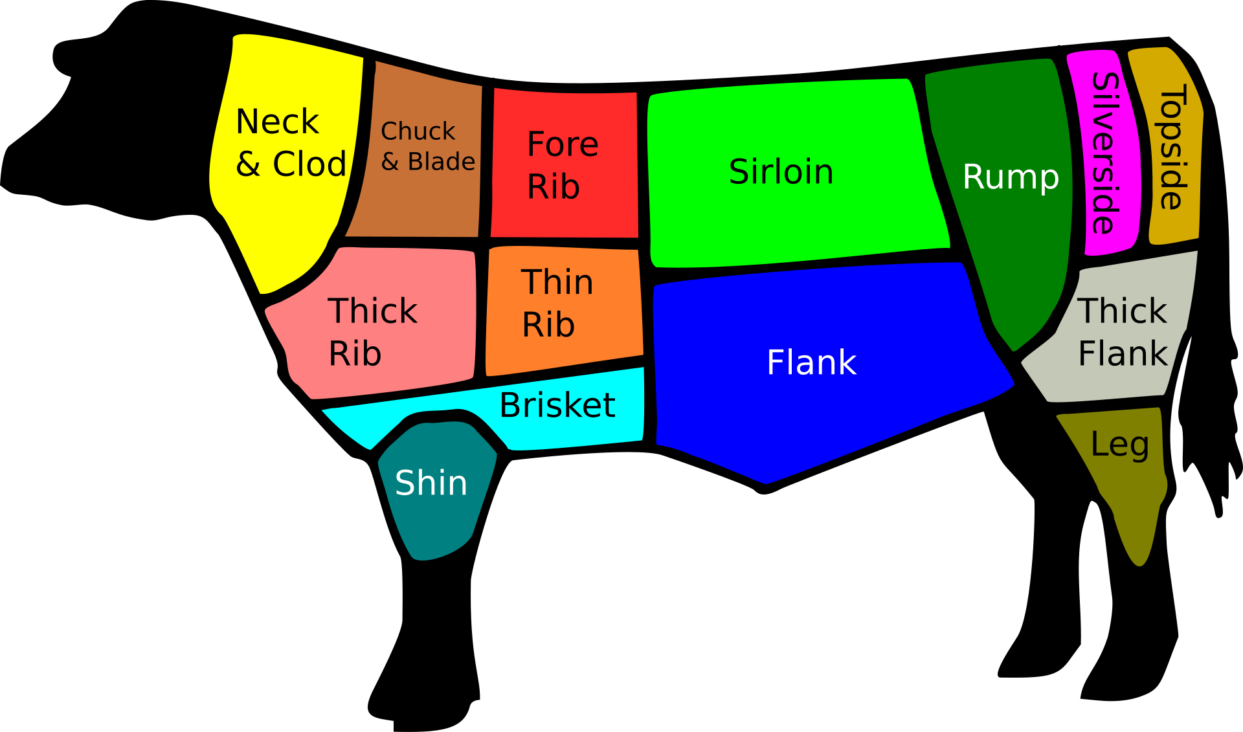
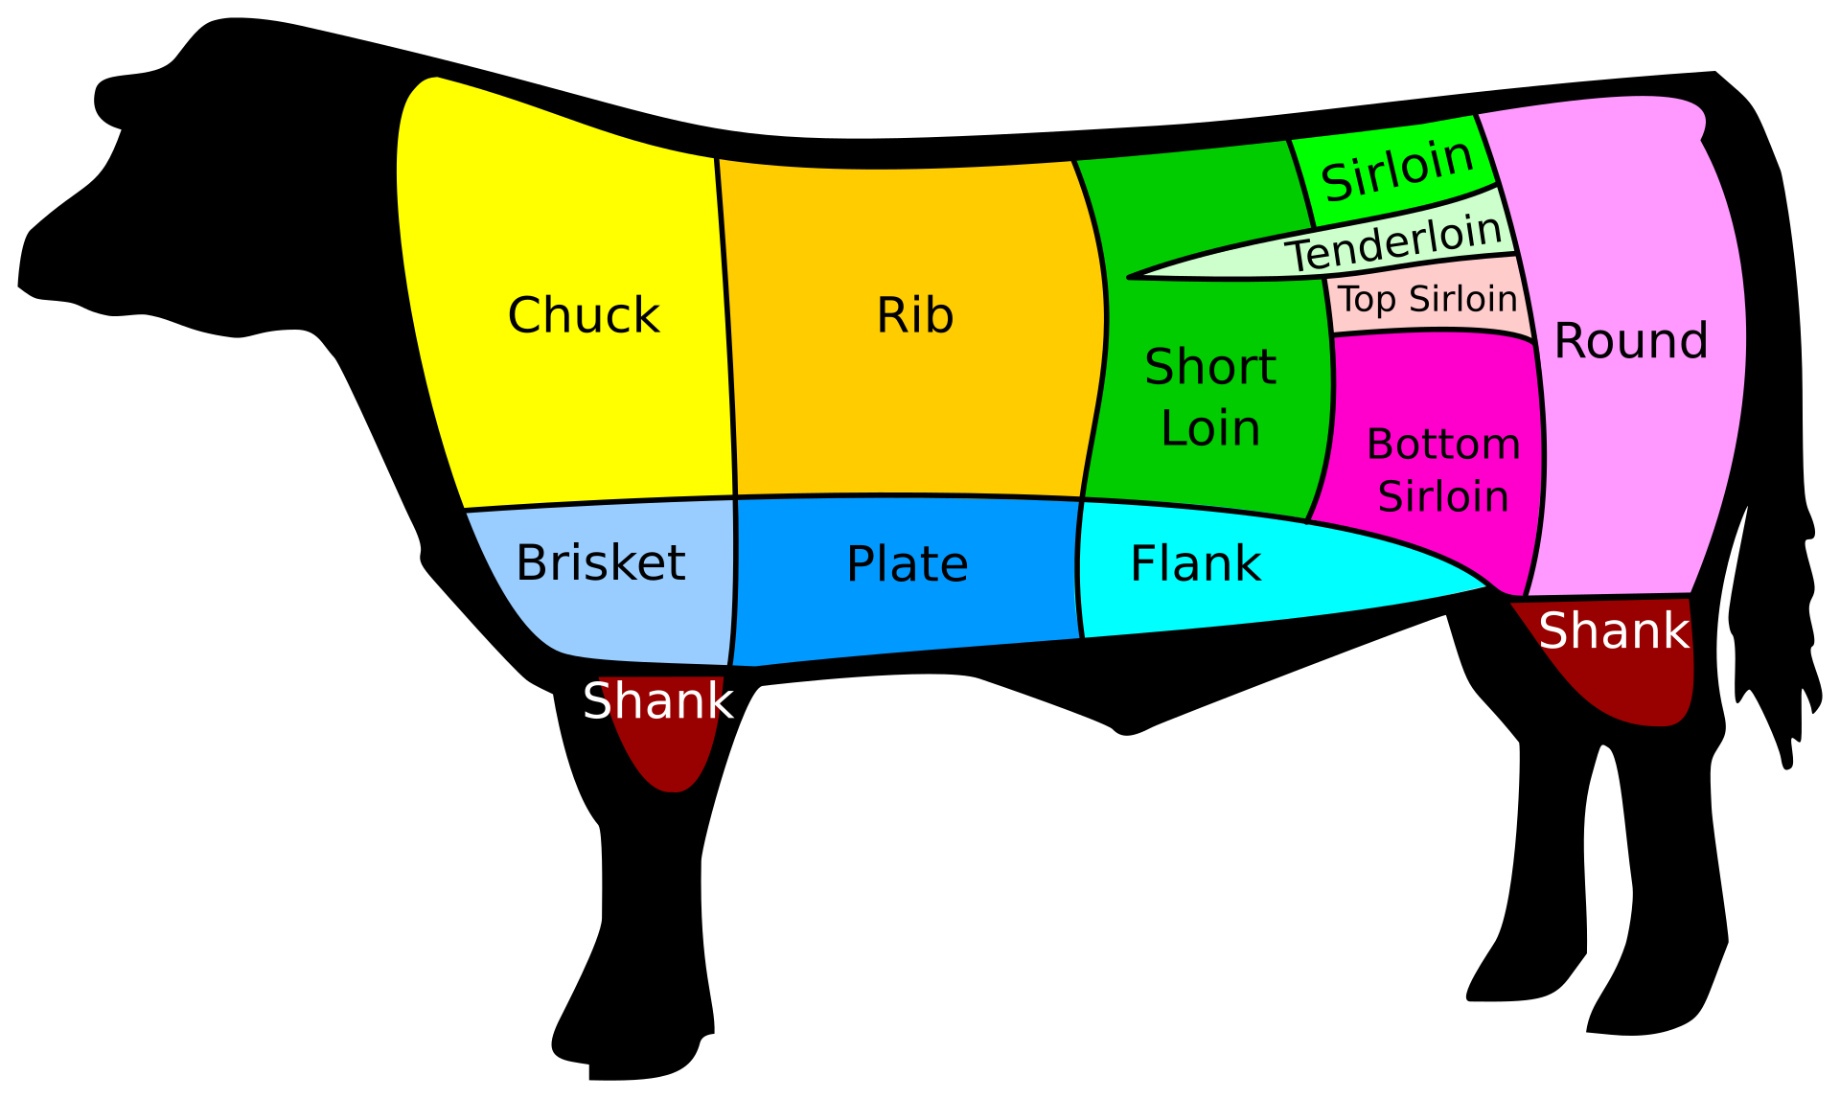
British beef cuts
(topside and silverside
are “lean” cuts) (magra)

USA beef cuts
(round and sirloin are “lean” cuts)

